Project 2

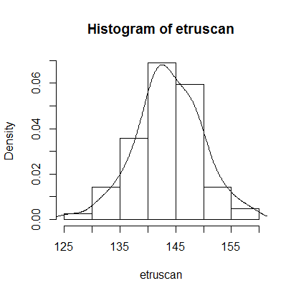

1.

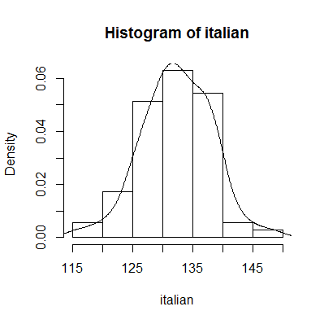

The shape of the histograms look very similar, but the Italians curve occurs 10mm before the Etruscans.

2.

|  |  |  |
| --- | --- | --- |
| Type\Dataset | Etruscan | Italian |
| Descriptive stat 1 | 126.000000 | 116.000000 |
| Descriptive stat 2 | 140.000000 | 129.000000 |
| Descriptive stat 3 | 143.500000 | 132.000000 |
| Descriptive stat 4 | 148.000000 | 137.000000 |
| Descriptive stat 5 | 158.000000 | 148.000000 |
| Mean | 143.773810 | 132.442857 |
| Standard Deviation | 5.970512 | 5.749948 |

The Descriptive stats, as with problem 1, seem to be set about 10mm apart. The Standard Deviation is very similar for both datasets. The one number that describes the difference between them is the Mean.

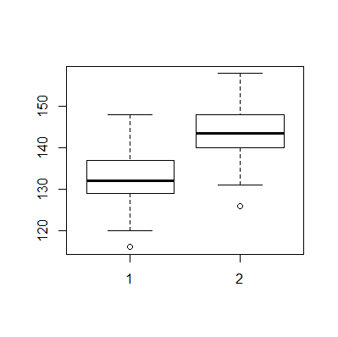

3. The boxplot with Italians on the left, and Etruscans on the right:

Once again, the difference is the spacing between them. The Etruscans are again 10mm larger than the Italians. I am happily surprised I managed to get both plots on the same graph. I kept on entering boxplot.default(dataset) individually, but then I tried boxplot.default(Italian,Etruscan), and R gave me this graph.

4. ipsd() returns an interquartile range of 8.000000 and a Standard Deviation of 5.970512 for the Etruscans, and an interquartile range of 8.000000 and a Standard Deviation of 5.749948 for the Italians.

5. This is the function I wrote:

fences <- function(x){

#returns lower and upper fences for a vector of data x

fn <- fivenum(x)

q1 <- fn[2]

q3 <- fn[4]

iq <- q3 - q1

lower <- q1 - 1.5*iq

upper <- q3 - 1.5*iq

return(c(lower,upper))

}

It told me that the lower fence for the Etruscans is 128, and the upper fence is 136. For the Italians, the lower fence is 117, and the upper fence is 125.

6. Let me just say: I am not qualified to answer this question with any confidence based off of head sizes. A complex analysis of DNA and such would be required to do this properly. For this project, though, I would say no. The head sizes may be similar in range and standard deviation, but they are 10mm apart. Then again, this could mean they are related. But for now, I’m saying no because of this size difference. If I had information of body dimensions, I could give a better analysis, but I’m going to stick with no.